How to Use AtMA Template in MS Word

Please submit your abstracts and papers using the AtMA Template in MS Word. Why? It allows quick updates to the Proceedings while ensuring consistency. It also makes the document more accessible via document readers with the use of headers and subheaders. Finally, this format is the same as required for submission to the Atlantic Marketing Journal making it easier on you. Please follow these steps to download and save the AtMA Template:

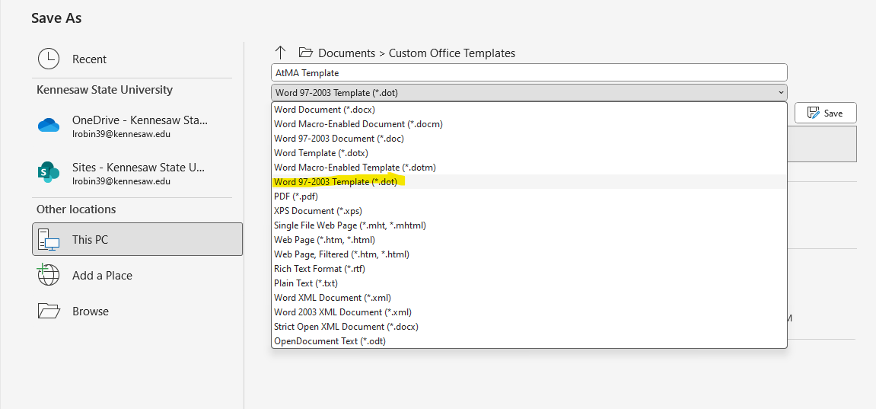
1. Open the AtMA Template in MS Word. SAVE AS a TEMPLATE:
2. Save a copy of the document as a Document file call: AtMA Template Overview. That will help you know which sections need to use which styles. USING AtMA Template

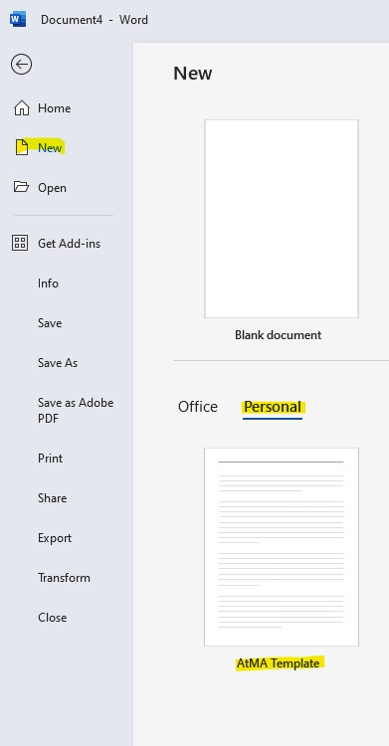
3. When you are ready to use the template, go to NEW Personal tab and select AtMA Template to open a new document with the AtMA Styles available. You can then write your paper and apply the styles as you go.
4. If you have already written your paper, you can copy and paste it into the new document. Then go back and apply the styles.
HINT: If you copied your paper onto the draft, select all (Ctrl+a) and then copy (Ctrl+v) it to the blank format as AtMA Normal. Then go back and format the titles, headers, sub-headers, etc.

Using Styles in MS Word
5. Now that your new document is saved a AtMA Normal with the AtMA Template Styles, you can reformat the key elements using those styles for: AtMA Title, AtMA Author, AtMA Headers, AtMA Sub-Headers and AtMA References. You may also need to use AtMA Sub-Sub-Headers and AtMA Table & Figure. These can be accessed several different ways:
A. Select Styles on the Home Tab and pick the appropriate style:
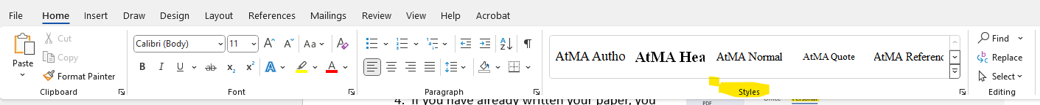
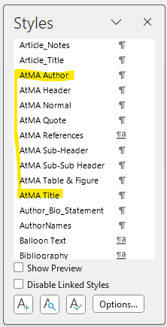
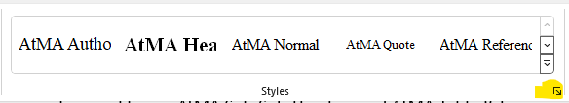
B. Select Styles on the Home Tab and expand using the arrow which opens a menu of all styles:

C. Select the word and right click to see the styles options: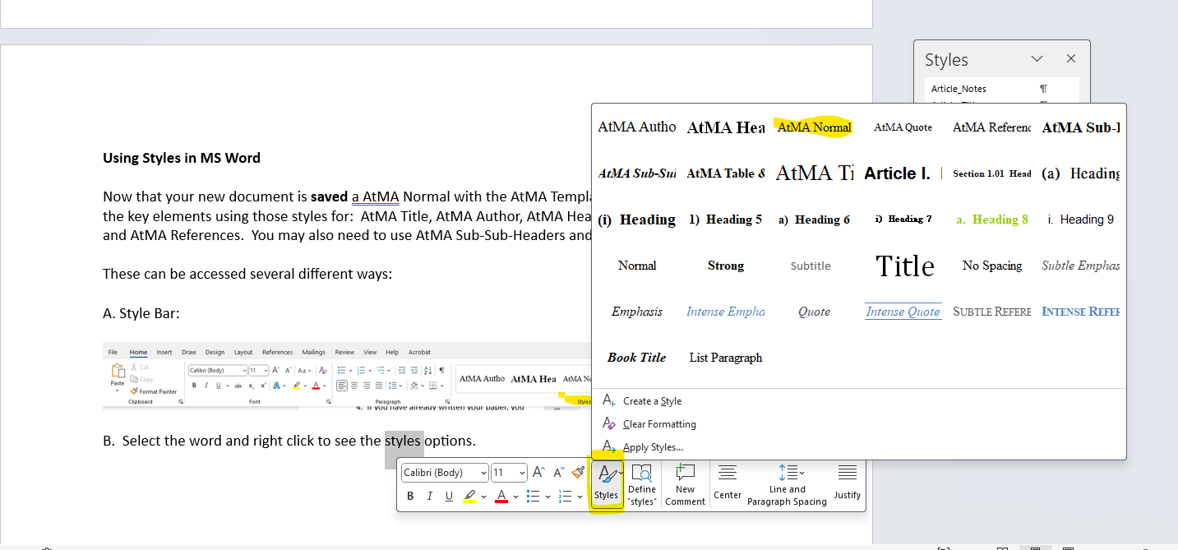

6. SAVE your abstract or paper as a WORD DOCUMENT (.DOCX) and submit using Digital Commons.

